Project Design Phase-II
Technology Stack (Architecture & Stack)

Date | 01 October 2026
Team ID | SWTID-2026-7653
Project Name | Script-Controlled ACL – Restrict Record Access Based on Field Value
Maximum Marks | 4 Marks

Technical Architecture:
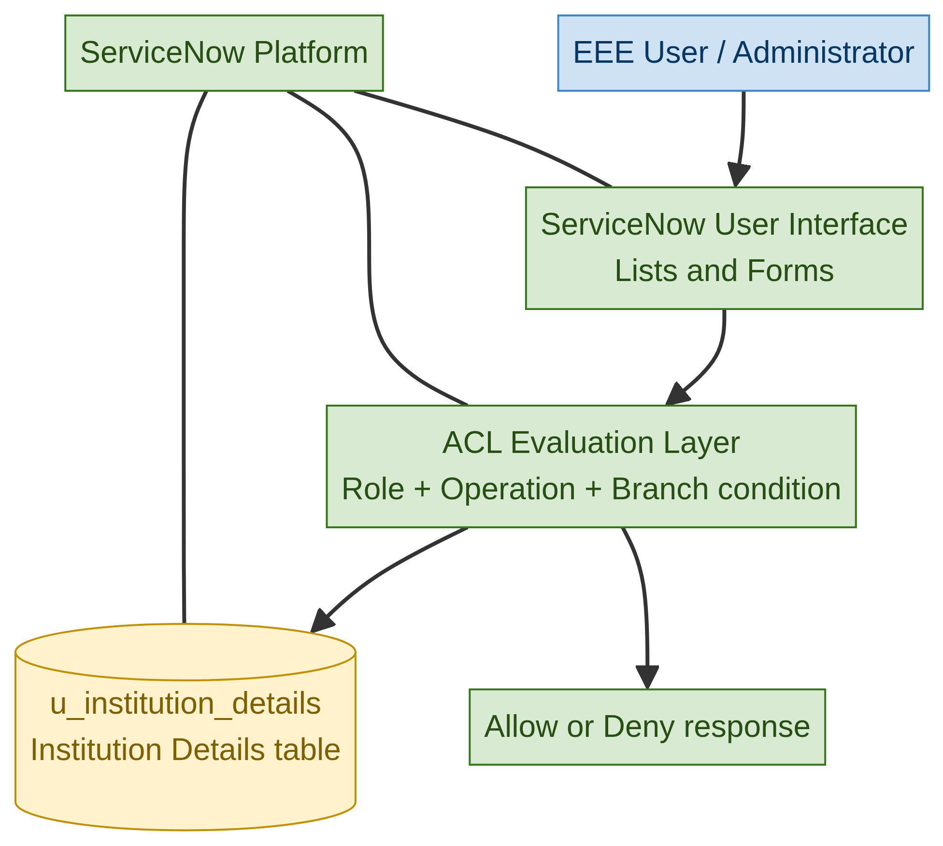
Project architecture: ServiceNow interface, ACL evaluation and u_institution_details table.

Table-1 : Components & Technologies:
S.No | Component | Description | Technology
1 | User Interface | Users access lists and forms in the ServiceNow instance. | ServiceNow UI (lists and forms)
2 | Application Logic-1 | Evaluates read access using roles, the Branch field and the ACL script. | ServiceNow ACL engine + server-side JavaScript
3 | Application Logic-2 | Evaluates create, write and delete permissions by required role. | ServiceNow record ACLs
4 | Application Logic-3 | Supports administration, impersonation and security verification. | ServiceNow administration and impersonation
5 | Database | Stores Institution Details records and fields including Branch, student and contact data. | ServiceNow table: u_institution_details
6 | Cloud Database | Managed persistence for the ServiceNow application data. | ServiceNow platform data store
7 | File Storage | No separate file storage is required by this ACL lab. | Not used in the project
8 | External API-1 | No external API is specified or required. | Not used in the project
9 | External API-2 | No external API is specified or required. | Not used in the project
10 | Machine Learning Model | No machine-learning model is specified or required. | Not used in the project
11 | Infrastructure (Server / Cloud) | The lab runs in a ServiceNow instance accessed through the platform. | ServiceNow hosted instance

Table-2: Application Characteristics:
S.No | Characteristics | Description | Technology
1 | Open-Source Frameworks | No separate open-source framework is used in the project. | Not applicable
2 | Security Implementations | Record-level ACLs; roles bb1, bb2, bb3 and bb4; Branch = EEE data condition; administrator bypass. | ServiceNow ACLs and server-side JavaScript
3 | Scalable Architecture | The project is a ServiceNow ACL lab, not a custom microservice architecture. Scaling is managed by the platform and was not independently evaluated. | ServiceNow platform
4 | Availability | Availability depends on the ServiceNow instance; no separate load-balancer or distributed deployment is specified in the project. | ServiceNow platform availability
5 | Performance | ACL checks are evaluated during table access; no request-per-second or latency target is specified. | ServiceNow ACL evaluation

